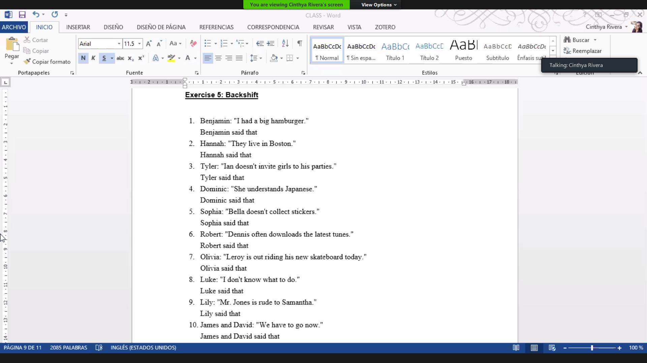

1. Benjamin said that he had had a big hamburger.
2. Hannah said that they lived in Boston.
3. Tyler said that Ian didn’t invite girls to his parties.
4. Dominic said that he understood Japanese.
5. Sophia said that Bella didn’t collect stickers.
6. Robert said that Dennis often downloaded the latest news.
7. Olivia said that Leroy was out riding his new skateboard today.
8. Luke said that he didn’t know what to do.
9. Lily said that Mr. Jones was rude to Samantha.
10. James and David said that they had to go then.